

# **LAB REPORT 5**

**RC CIRCUIT**

**Date of Experiment:**

**Date of Report:**

**Members:**



**PROCEDURE A:**

**Charging the Capacitor**



|  |  |  |  |  |  |  |  |  |
| --- | --- | --- | --- | --- | --- | --- | --- | --- |
|  | **Theoretical** | | | **Experimental Determinations of the Time Constant** | | | | |
|  | 1 | 2 | | 3 | |
|  |  |  |  | (time to 63% Vmax) | (time to 50% Vmax) |  |  |  |
| **Case 1** | **986Ω** | **330µF** | **0.325s** | 0.29 | 0.2 | 0.29 | 2.925 | 0.3 |
|  |  | z | % errors: | **10** |  | **10** |  | **7.7** |
|  |  |  |  |  |  |  |  |  |
| **Case 2** | **3840Ω** | **330µF** | **1.27s** | 1.16 | 0.81 | 1.16 | 11.43 | 1.15 |
|  |  |  | % errors: | **8.66** |  | **8.66** |  | **9.44** |
|  |  |  |  |  |  |  |  |  |
| **Case 3** | **3260Ω** | **330µF** | **1.08s** | 0.99 | 0.69 | 0.99 | 9.72 | 1 |
|  |  |  | % errors: | **8.3** |  | **8.3** |  | **7.4** |

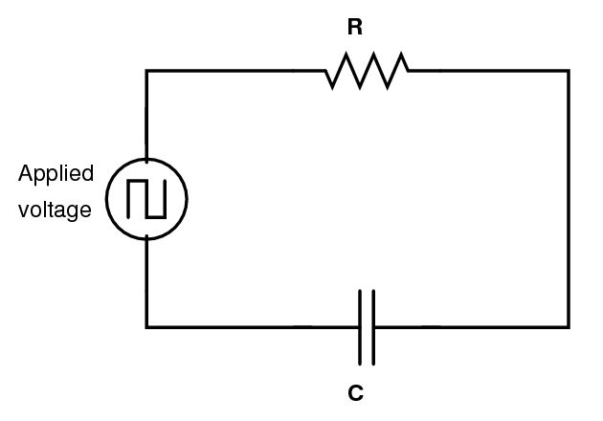**PROCEDURE B:**

**Discharging the Capacitor**

|  |  |  |  |  |  |  |  |  |  |
| --- | --- | --- | --- | --- | --- | --- | --- | --- | --- |
|  | Theoretical | | | Discharging  Process | | | Half Life | Time constant | Time constant |
|  |  |  |  | Started at | 50% max | 37% max |
| **Case 1** | **986Ω** | **330µF** | **0.325s** | 2.83 | 3.04 | 3.13 | 0.21 | 0.3 | 0.3 |
|  |  |  |  |  |  |  | %  Errors: | **7.69** | **7.69** |
|  | 0.169 | |  |  |  |  |  |  |  |
|  |  |  |  |  |  |  |  |  |  |
| **Case 2** | **3840Ω** | **330µF** | **1.27s** | 11.5 | 12.3 | 12.7 | 0.8 | 1.15 | 1.2 |
|  |  |  |  |  |  |  | %  Errors: | **9.44** | **5.5** |
|  | 0.043 | |  |  |  |  |  |  |  |
| **Case 3** | **3260Ω** | **330µF** | **1.08s** | 9.69 | 10.39 | 10.7 | 0.7 | 1 | 1.01 |
|  |  |  |  |  |  |  | %  Errors: | **7.4** | **6.48** |
|  | 0.051 | |  |  |  |  |  |  |  |
|  |  | |  |  |  |  |  |  |  |

**QUESTIONS PROCEDURE A:**

**Charging the Capacitor**

1. Compare the time constants () with the changing of resistance R in three cases above.

Compare all results of whole 3 experiments, it can be seen that the bigger the magnitude of resistant is, the slower the time constant it taken for the capacitor to charge to 63.2% of its maximum voltage. The 2nd one is the slowest - The 3rd - And then the 1st is the fastest

1. Compare the times to fully charge  with the changing of time constants () in three cases above.

Just as the time constant, the times to fully charged all three circuit in three cases above were all affected by the resistant, so the 2rd is the longest, the 3nd is less slower than the the 2nd one, and the 1st is the fastest due to their resistant rank from the biggest to the smallest.

1. Given that, what was the maximum current stored in the capacitor in each case? Show the calculations here:

All cases have the same C and V (all measured at 4V with C = 330µF) so the q of all is the same. Hence, q = CV= $330×{10}^{-6}×4= 1.32 ×{10}^{-3}$

1. What are some factors that could account for the difference between the theoretical and experimental values? Which experimental value of time constant, if any, has the largest uncertainty? Explain.

Several factors could account for the difference between the theoretical and experimental values in an RC circuit experiment:

* **Measurement Accuracy**: The precision of the instruments used to measure resistance, capacitance, and time can significantly affect the results. Any error in these measurements will directly impact the calculated time constant.
* **Component Quality**: Real-world resistors and capacitors may not behave exactly as ideal components due to manufacturing variances, temperature effects, and other factors.
* **Experimental Conditions**: Factors such as temperature, humidity, and electromagnetic interference can also affect the behavior of the components and the measurements.
* **Human Error**: The skill and precision of the person conducting the experiment can also introduce error. This includes timing accuracy when measuring how long it takes for the capacitor to charge or discharge.

The experimental value of time constant has the largest uncertainty is Experimental Determinations of the Time Constant 3 of case 2 with error is 9.44%. The explaination is it may be due to errors coming from $t_{\text{full}}$ so that the result from the formula differs so much from the measured number.

**QUESTIONS PROCEDURE B:**

**Discharging the Capacitor**

1. Was the half-life for charging the same as the half-life for discharging?

The half-life for charging for each case respectively is:

* Case 1: 0.2s
* Case 2: 0.81s
* Case 3: 0.69s

The half-life for discharging for each case respectively is:

* Case 1: 0.2s
* Case 2: 0.81s
* Case 3: 0.7s

From this, we can conclude that the half-life for charging and the half-life for discharging are the same, with a difference of no more than 0.01 second.

1. Which circuit discharges faster, the one with higher $τ$ or the one with lower?

The circuit with a lower τ discharges faster. Here, τ is the time constant of an RC (Resistor-Capacitor) circuit, which is calculated as the product of the resistance R and capacitance C. The time constant τ represents the time it takes for the charge or voltage to increase to approximately 63.2% of its maximum value during charging or decrease to approximately 36.8% of its initial value during discharging. Therefore, a lower τ means the circuit will charge or discharge more quickly.